**Insert School Logo**

**Semester Two**

**Examination 2020**

**Question/Answer booklet**

**MATHEMATICS**

**METHODS UNITS 3 & 4**

**Section Two:**

**Calculator–assumed**

|  |
| --- |
| Student Name: _____________________________________ |
| Teacher’s Name: _____________________________________ |

**Time allowed for this section**

Reading time before commencing work: ten minutes

Working time for paper: one hundred minutes

**Material required/recommended for this section**

**To be provided by the supervisor**

This Question/Answer booklet

Formula Sheet (retained from Section One)

**To be provided by the candidate**

Standard items: pens (blue/black preferred), pencils (including coloured), sharpener, correction tape/fluid, erasers, ruler, highlighters

Special Items: drawing instruments, templates, notes on two unfolded sheets of A4 paper, and up to three calculators approved for use in the WACE examinations.

**Important note to candidates**

No other items may be taken into the examination room. It is **your** responsibility to ensure that you do not have any unauthorised notes or other items of a non–personal nature in the examination room. If you have any unauthorised material with you, hand it to the supervisor **before** reading any further.

**Structure of this paper**

|  |  |  |  |  |  |
| --- | --- | --- | --- | --- | --- |
|  | Number of questions available | Number of questions to be attempted | Working time (minutes) | Marks available | Percentage of exam |
| Section One  Calculator—free | 7 | 7 | 50 | 50 | 35 |
| **Section Two**  **Calculator—assumed** | **13** | **13** | **100** | **100** | **65** |
|  | | | | Total Percentage | 100 |

**Instructions to candidates**

1. The rules for the conduct of Western Australian external examinations are detailed in the

*Year 12 Information Handbook 2020.* Sitting this examination implies that you agree to abide by these rules.

1. Answer the questions according to the following instructions.

**Show all your working clearly.** Your working should be in sufficient detail to allow your

answers to be checked readily and for marks to be awarded for reasoning. Incorrect answers given without supporting reasoning cannot be allocated any marks. For any question or part question worth more than two marks, valid working or justification is required to receive full marks. If you repeat an answer to any question, ensure that you cancel the answer you do not wish to have marked.

It is recommended that you **do not use pencil**, except in diagrams.

1. You must be careful to confine your responses to the specific questions asked and to follow any instructions that are specific to a particular question.
2. Spare pages are included at the end of this booklet. They can be used for planning your responses and/or as additional space if required to continue an answer.

* Planning: If you use the spare pages for planning, indicate this clearly at the top of the page.
* Continuing an answer: If you need to use the space to continue an answer, indicate in the original answer space where the answer is continued, i.e. give the page number. Fill in the number of the question that you are continuing to answer at the top of the page.

1. The Formula Sheet is **not** handed in with your Question/Answer Booklet.

# Section Two: Calculator–assumed 65% (100 marks)

This section has **thirteen (13)** questions. Attempt **all** questions. Write your answers in the spaces

provided.

Spare pages are included at the end of this booklet. They can be used for planning your responses

and/or as additional space if required to continue an answer.

* Planning: If you use the spare pages for planning, indicate this clearly at the top of the page.
* Continuing an answer: If you need to use the space to continue an answer, indicate in the original answer space where the answer is continued, i.e. give the page number. Fill in the number of the question(s) that you are continuing to answer at the top of the page.

Working time: 100 minutes

**Question 8 (7 marks)**

The following function is a pdf on the given interval.

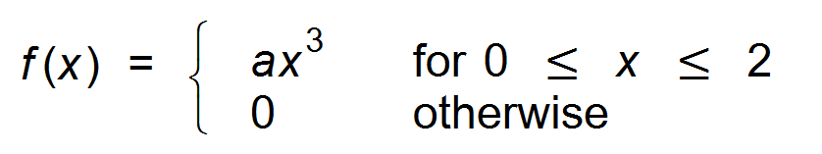

(a) Show that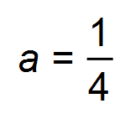. (2 marks)

(b) Find the probability that x < 1. (2 marks)

(c) Determine the upper quartile of the distribution. (3 marks)

**Question 9 (6 marks)**

The function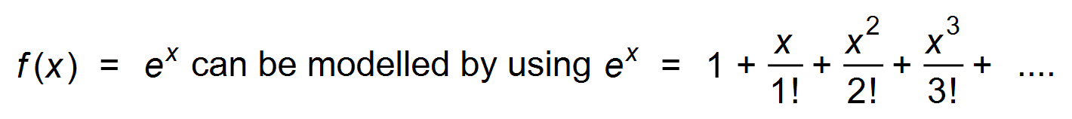

(a) Calculate *f* (2):

(i) correct to three decimal places. (1 mark)

(ii) by using an approximation based on the first five terms of the expansion. (1 mark)

(b) Use the first five terms of the sequence to determine an approximation for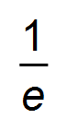. (2 marks)

(c) Use the model to show that 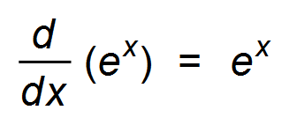. (2 marks)

**Question 10 (8 marks)**

The surface temperature, in °C, of a cake t seconds after it has been taken from the oven

is given by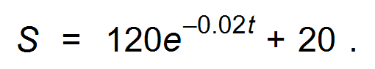

(a) What is the temperature of the cake when it first taken from the oven? (1 mark)

(b) What is the temperature of the cake two minutes after removal from the oven? (2 marks)

(c) Erica will ice the cake once it is at room temperature. If room temperature is 25°,

how long, to the nearest minute, will Erica need to wait to ice the cake? (3 marks)

(d) At what rate is the cake cooling half a minute after being removed from the oven? (2 marks)

**Question 11 (17 marks)**

A population of males had blood pressure readings (*x* mm), which were normally distributed

with a mean of 85 mm and a standard deviation of 20 mm.

(a) What percentage of these males had blood pressure of less than 110 mm? (2 marks)

(b) Fifteen of these males were selected at random. What is the probability that:

(i) exactly ten had blood pressure of less than 110 mm? (2 marks)

(ii) the first three selected had blood pressure of less than 110, and at least

half of the others also had blood pressure of less than 110 mm? (3 marks)

Medication is prescribed for males with blood pressure readings (bp) consistently higher than 110 mm.

The cost ($*y*) depends on the bp, and is shown below.

|  |  |  |  |
| --- | --- | --- | --- |
| *x* | Given x ≥ 110,  *x* < 115 | Given *x* ≥ 110,  115 ≤ *x* ≤ 120 | Given *x* ≥ 110,  *x* ≥ 120 |
| *y* | $10 | $20 | $30 |
| P(Y = *y*) | **0.3677** | **0.2532** | **0.3792** |

(c) Show calculations that verify the bold entries, P(Y = *y*), for $10, $20 and $30. (3 marks)

(d) For people in need of medication for high blood pressure, calculate the mean cost of that medication per person. ( ie. E(Y) ). (2 marks)

(e) Determine the standard deviation for medication costs. Show your calculation. (3 marks)

(f) The costs of medication increase by 20%, but the National Health Scheme subsidises the increase by an amount of $1 per script.

State the new mean and standard deviation of expected costs for people needing such medication. (2 marks)

**Question 12 (10 marks)**

A model boat race takes place on a suburban lake. James’ boat leaves the starting buoy

with a velocity given by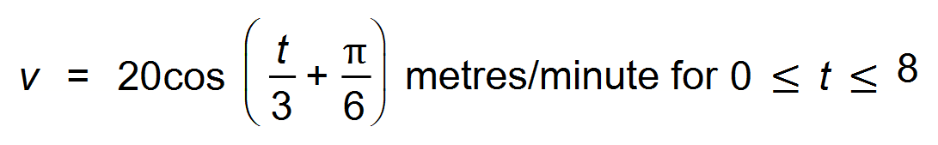where *t* is

the time from leaving the starting buoy. It travels towards the farthest buoy, where it turns

and returns to the start.

(a) Determine:

(i) the velocity when it leaves the starting buoy for the first time. (1 mark)

(ii) the maximum velocity reached by the boat. (1 mark)

(b) Determine *x*(*t*), the displacement of the boat at *t* minutes, given that *x*(0) = 0. (3 marks)

(c) At four minutes after starting;

(i) what is the displacement of the boat? (1 mark)

(ii) what direction, towards or away from the starting buoy, is the boat travelling? (1 mark)

On its **return journey**, at a particular time the boat is accelerating at 5 m/min2.

(d) How far has the boat travelled up till that point? (3 marks)

**Question 13 (10 marks)**

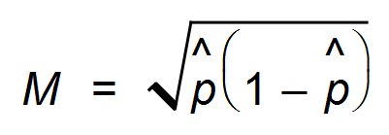

It is known that the maximum value of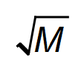occurs when M is a maximum.

(a) Sketch a relevant graph to show that the maximum value of M occurs when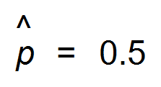

Label the axes clearly. (2 marks)

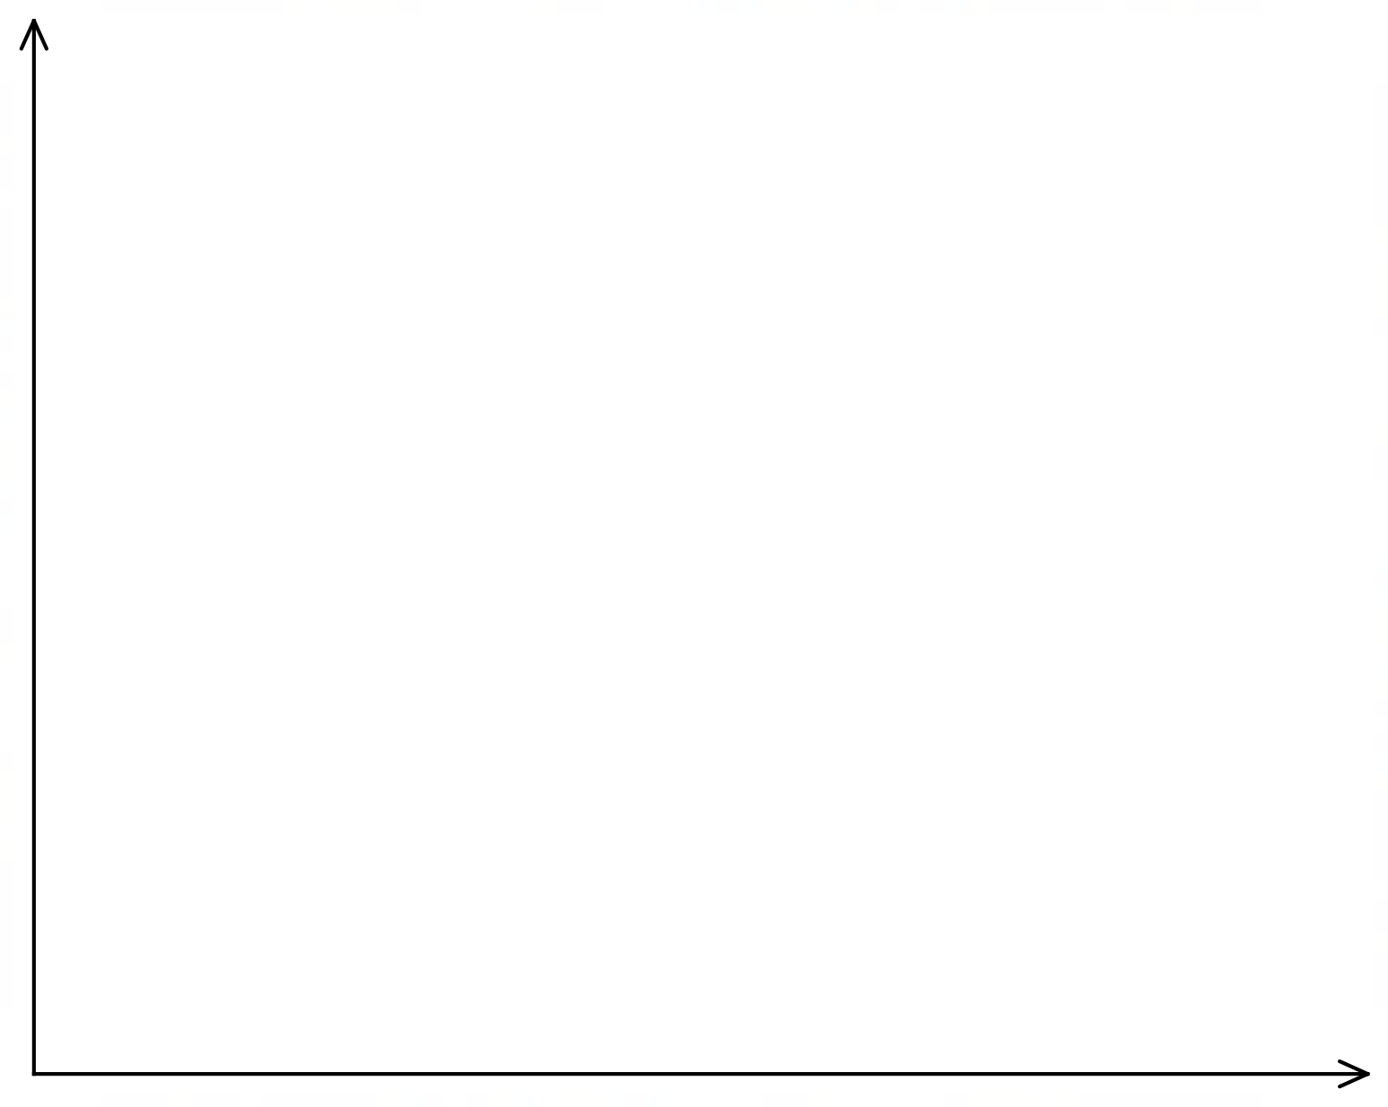

The proportion of qualified trainers in industry approved by the Training Council is p.

An audit of trainers in the iron−ore industry is used to determine p with a margin of error of 6% and a 95% level of confidence.

(b) How many trainers should be tested at a random check? (4 marks)

The Training Council conducts a similar audit on the gold mining industry in WA.

A 95% confidence interval for the proportion of trainers who are suitably qualified

was given as (0.72, 0.88).

(c) Determine how many trainers in the sample were deemed qualified. (4 marks)

**Question 14 (15 marks)**

The manufacturer of BWM drones believes that 4% of their drones have a performance defect. A sample of three hundred drones are recalled and tested.

(a) If the figure of 4% is correct, what is the probability distribution of the sample proportion of

defective drones in samples of size three hundred? (3 marks)

(b) Use your answer from (a) to determine the approximation of the probability that the next sample proportion from a sample of three hundred is less than 0.045? (2 marks)

(c) Calculate a 95% confidence interval for the proportion of defective drones produced.

(3 marks)

The magazine, Drones Today, claimed that twenty four of the BWM drones were defective in their sample of three hundred.

(d) Based on your calculation in (c) comment on the accuracy of their claim. (3 marks)

Another magazine, Drones Tomorrow, asked users to state their preference between BWM drones and MURK drones. 52 % of those sampled preferred MURK. The management of BWM asked for a new sample of a different size in order to increase accuracy.

(e) (i) Should the new sample size be larger or smaller than the original sample size

to increase the accuracy of the result? Explain briefly. (2 marks)

(ii) For a confidence level of 98%, state, correct to three decimal places, the number of standard deviations which make up the margin of error. (2 marks)

**Question 15 (6 marks)**

The graph of y = f (x) is shown below.

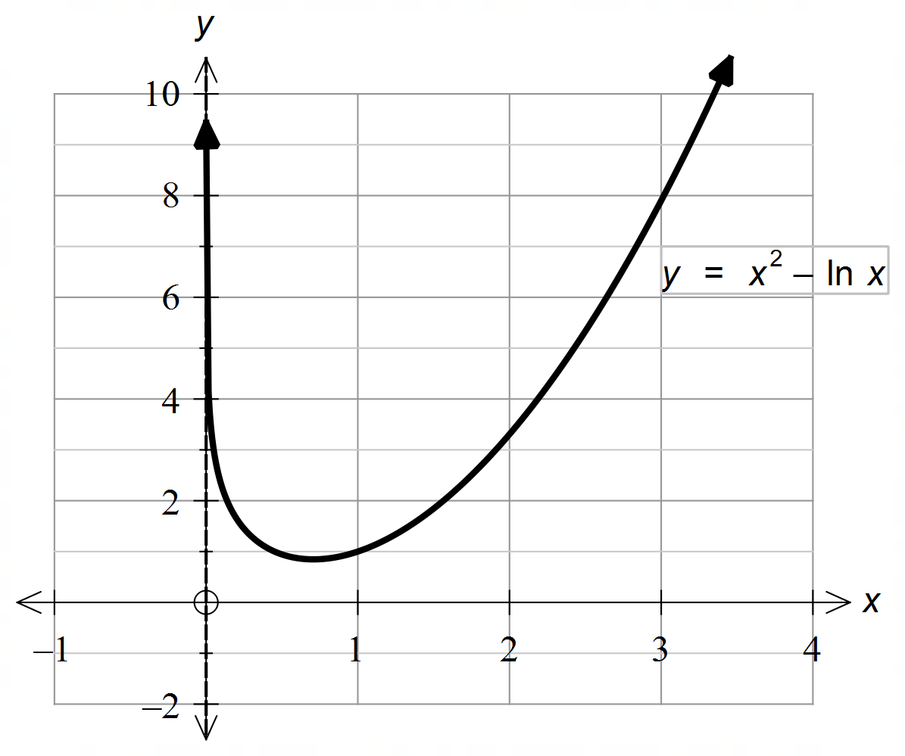

(a) Why is there a vertical asymptote at x = 0? (1 mark)



(b) Use Calculus to determine the exact co−ordinates of the global minimum point. (5 marks)

**Question 16 (8 marks)**

The graph of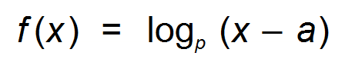is shown below.

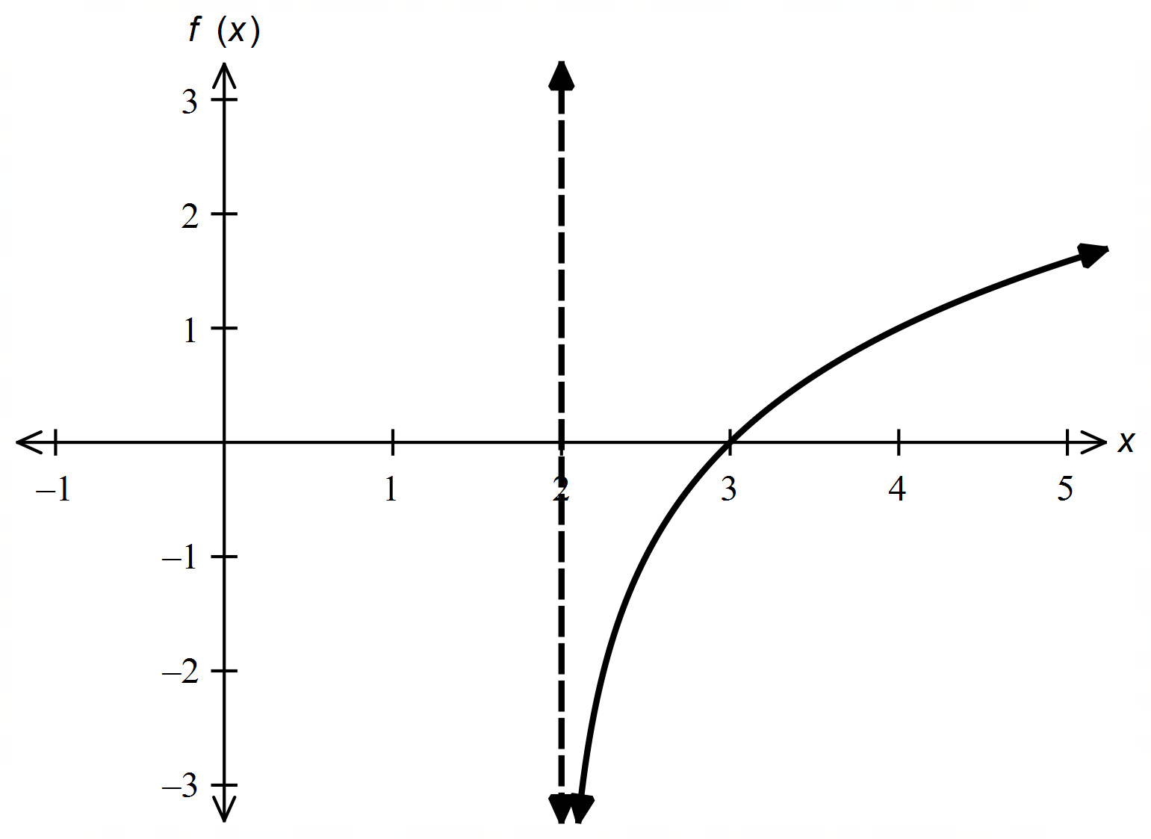

(a) Use the graph to state:

(i) the equation of the vertical asymptote. (1 mark)

(ii) the value of a. (1 mark)

(iii) why p cannot be evaluated. (1 mark)

(c) If the horizontal axis was translated down by one unit, determine the x−intercept of

the graph produced in terms of p. (3 marks)

(b) If f (27) = 2, determine p. (2 marks)

**Question 17 (6 marks)**

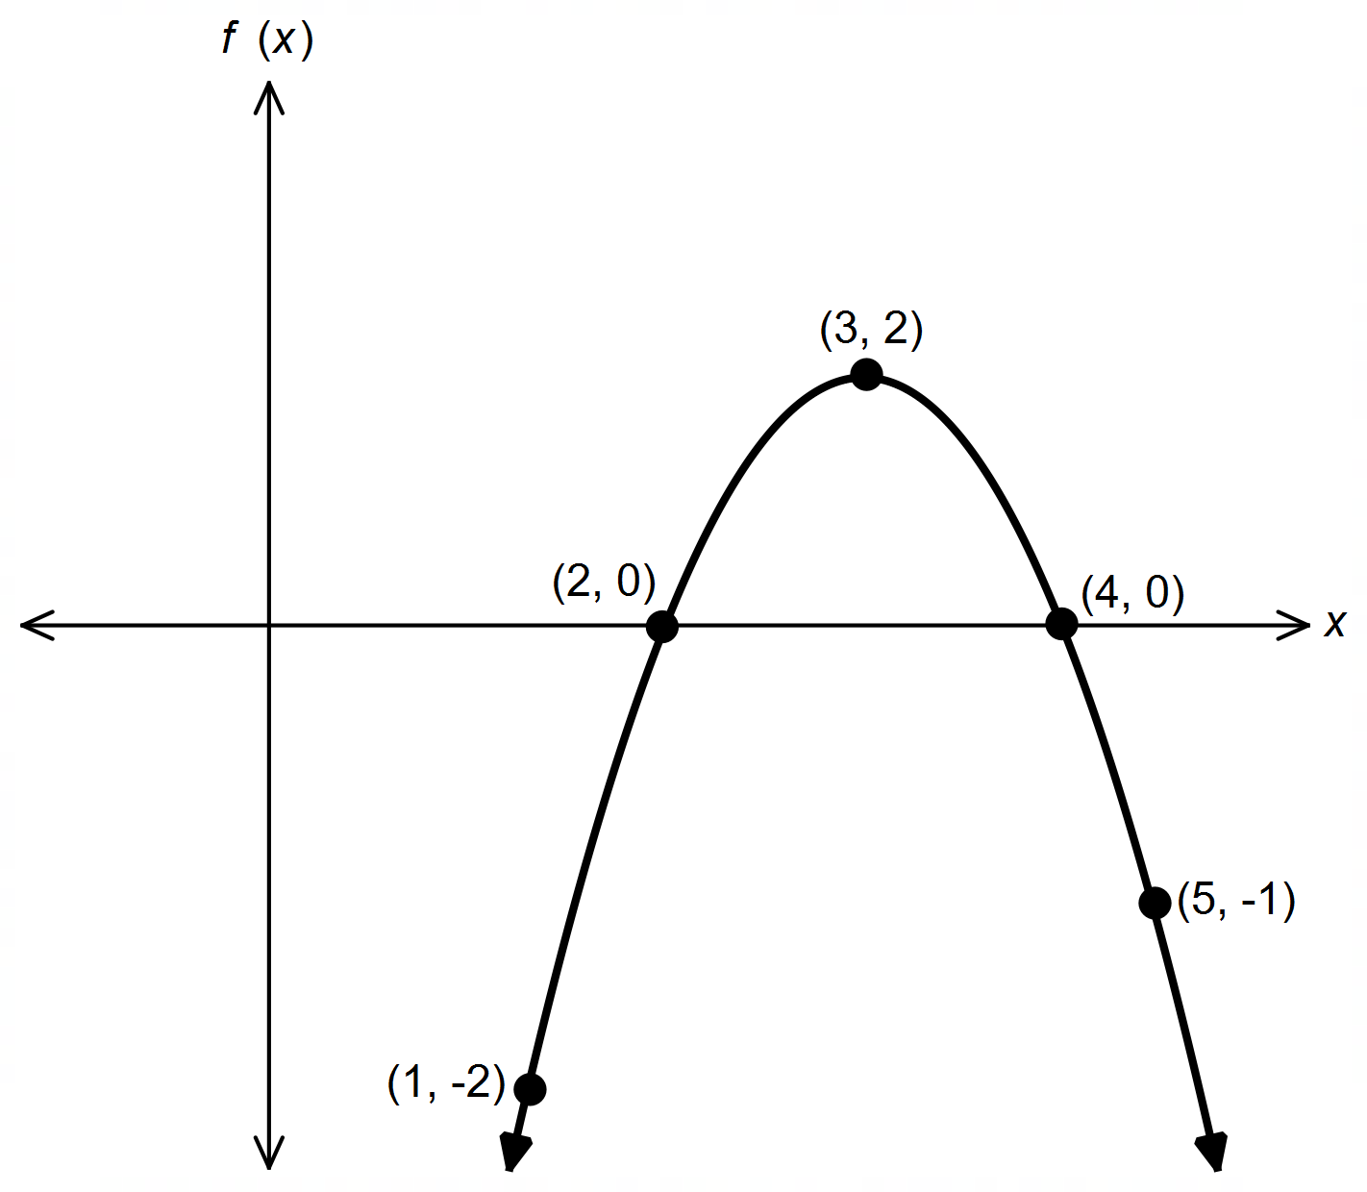

(a) Determine 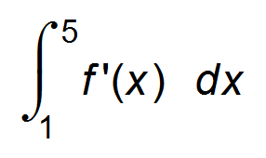. (2 marks)

(b) Calculate the area bounded by the graph of f ′(x) and the x−axis between x = 1 and x = 5. (4 marks)

**Question 18 (7 marks)**

The following function is used to model the relationship between weight (*w* kg) and height (*h* m) for adult giraffes.

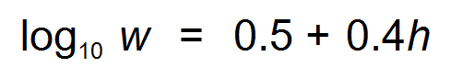

(a) Determine the weight of a 4 m tall giraffe. (2 marks)

(b) Determine the height of a giraffe weighing 180 kg. (2 marks)

(c) By what percentage is a 200 kg giraffe taller than a 100 kg giraffe? (3 marks)

**End of questions**

**Additional working space**

Question number(s): ……………………

**Additional working space**

Question number(s): ……………………